Ben Brandhorst
SDEV 300 6380
Building Secure Web Applications
Professor Craig Poma
06/23/2019

Introduction to OWASP ZAP

MANUALLY DETECTED VULNERABILITIES
1.) HTTP Username and Password Interception
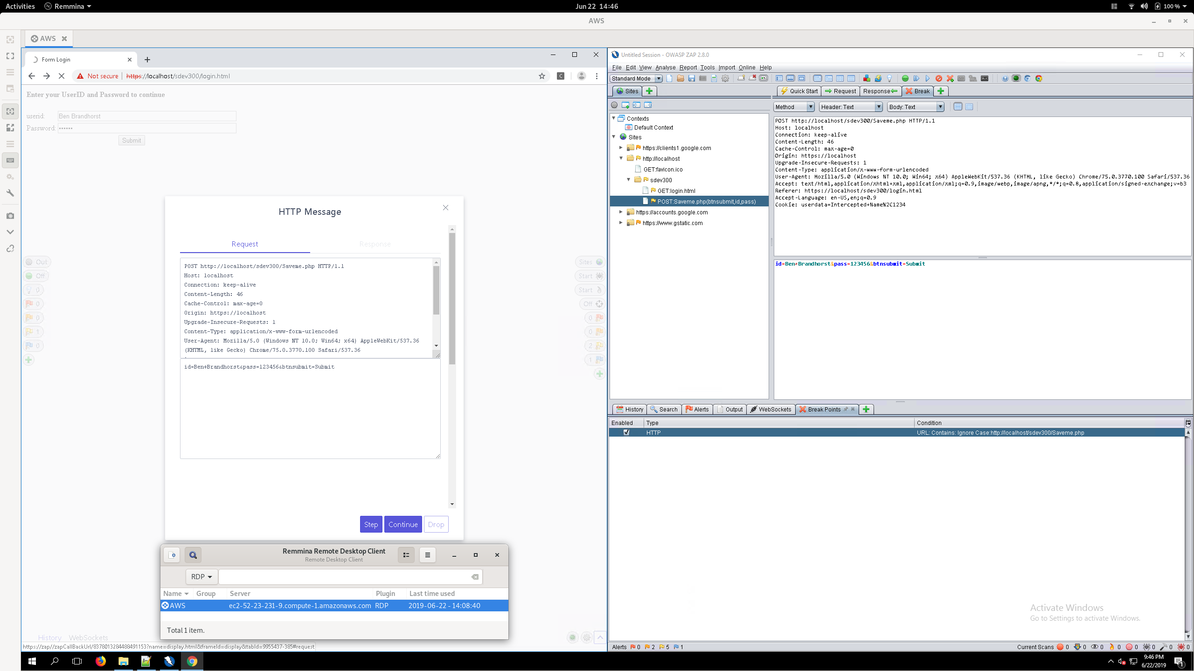

Changed Username
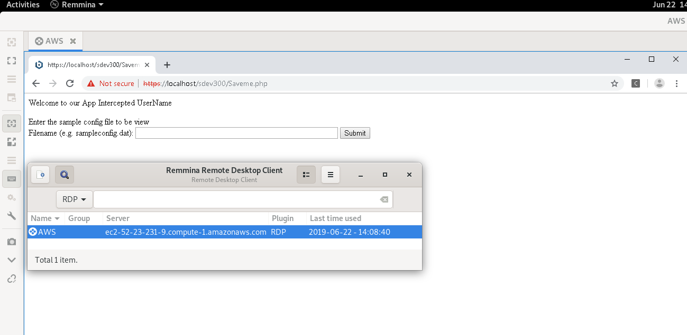

Intercepting user input has been corrected by adding the following entry in httpd.conf file:
Header set Strict-Transport-Security "max-age=31536000; includeSubDomains; preload"
This forces the site to use HTTPS which will help mitigate risks by use of encryption.

2.) Despite Using Login, Pages Don’t Require Users to be Logged In to Access Them
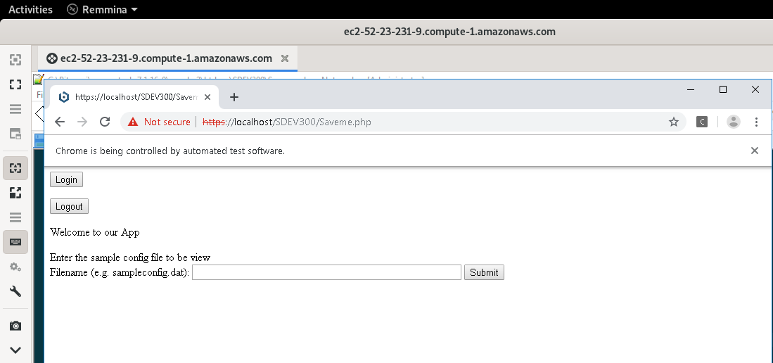

This has been corrected by adding Session data to each of the pages and creating a separate Logout page that uses session_destroy(), session_unset(), and setcookie() to delete session content and cookies. Now each page checks to verify the user is logged in before allowing access to it’s content.

Session Setting and Checking:
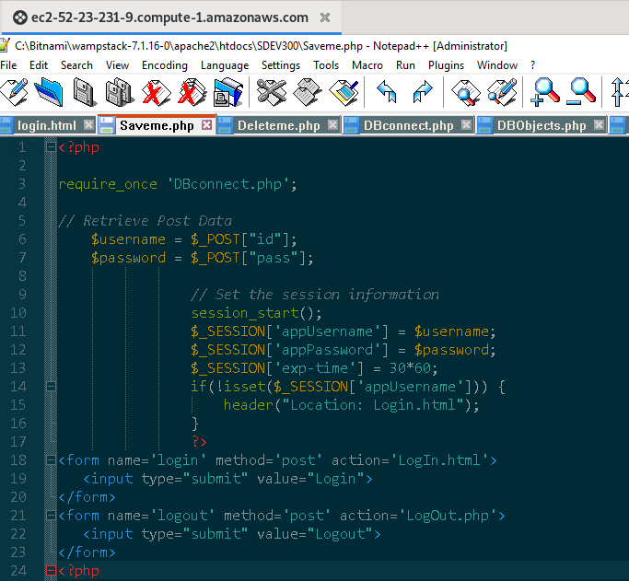

Logout
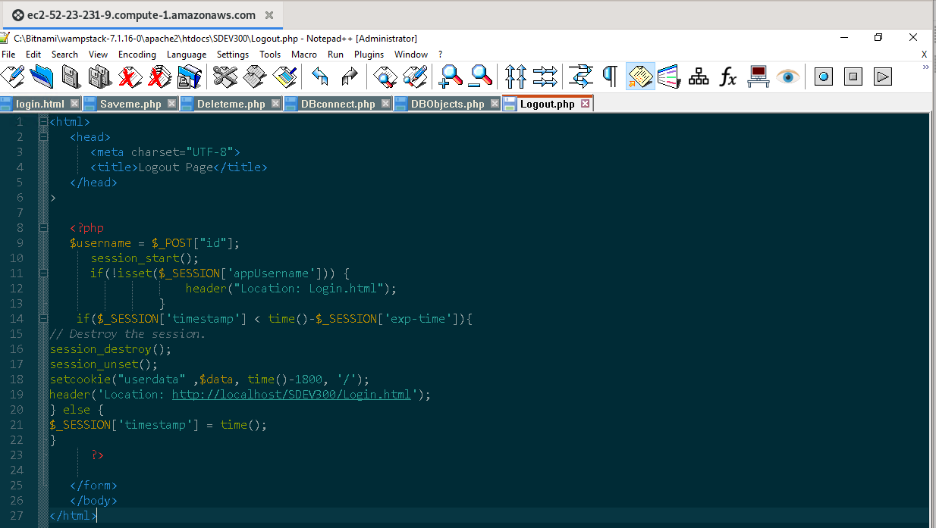

3.) Saveme.PHP allows users to use commands to navigate the file system and view the contents of files that should not be accessible.
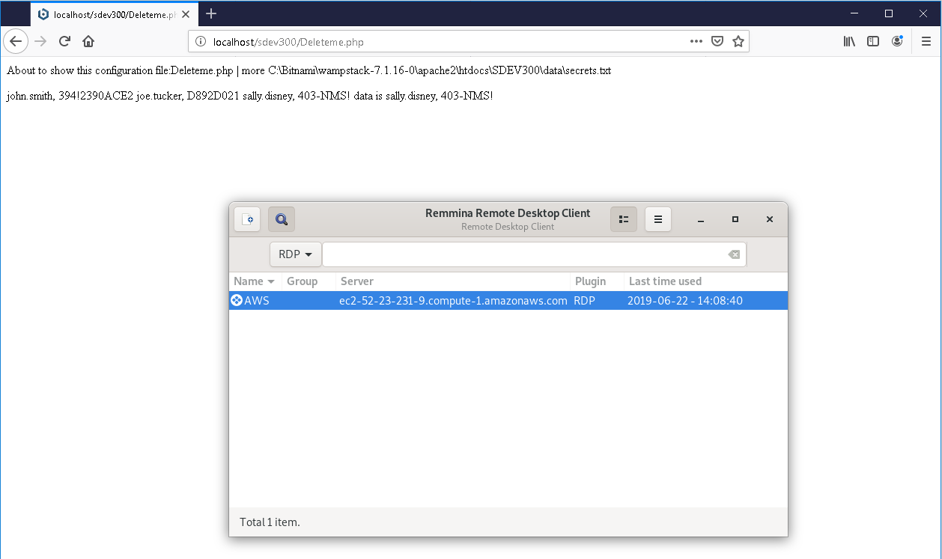

This has been corrected through the use of filter_var($file, FILTER_SANITIZE_ENCODED); which removes special characters and mitigates the risk of users accessing unauthorized areas.

Sanitized Input of (deleteme.php | dir)
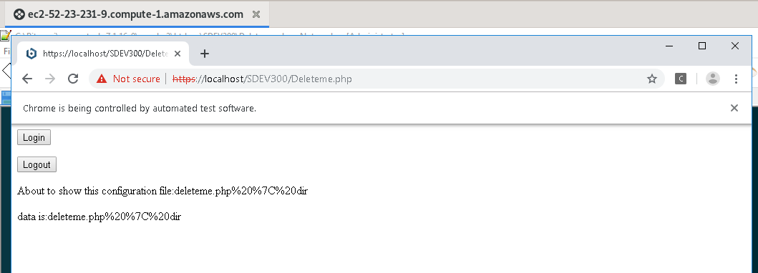

ZAP TOOL ASSISTED VULNERABILITIES DETECTED

My priorities in fixing issues were to start with the highest risk and move down the list. I tried applying each fix and then scanning again to see if it remained an issue.

Alert <1>: <Cross Site Scripting (Reflected)> – <High (Medium)>
Description: Cross-site Scripting (XSS) is an attack technique that involves echoing attacker-supplied code into a user's browser instance. When an attacker gets a user's browser to execute his/her code, the code will run within the security context (or zone) of the hosting web site. With this level of privilege, the code has the ability to read, modify and transmit any sensitive data accessible by the browser.

Risk Locations: http://localhost/SDEV300/Saveme.php
Solution: Added the following to the httpd.conf file:

<IfModule mod_headers.c>
Header set X-XSS-Protection "1; mode=block"
</IfModule>

and restarted the Apache Web Server

This will block pages from loading when they detect reflected XSS attacks.

Alert <2>: <Directory Browsing> – <Medium (Medium)>
Description: Cross-site Scripting (XSS) is an attack technique that involves echoing attacker-supplied code into a user's browser instance. When an attacker gets a user's browser to execute his/her code, the code will run within the security context (or zone) of the hosting web site. With this level of privilege, the code has the ability to read, modify and transmit any sensitive data accessible by the browser.

Risk Locations: http://localhost/SDEV300/, http://localhost/SDEV300/data, http://localhost/img/
Solution: Added the following to the httpd.conf file:

<Directory "C:/Bitnami/wampstack-7.1.16-0/apache2/htdocs/SDEV300">
Options FollowSymLinks
AllowOverride None
Require all granted
</Directory>
<Directory "C:/Bitnami/wampstack-7.1.16-0/apache2/htdocs/SDEV300/data">
Options FollowSymLinks
AllowOverride None
Require all granted
</Directory>
<Directory "C:/Bitnami/wampstack-7.1.16-0/apache2/htdocs/img">
Options FollowSymLinks
AllowOverride None
Require all granted
</Directory>

and restarted the Apache Web Server

This prevents Directories from being browsed.

Alert <3>: <Application Error Disclosure> – <Medium (Medium)>
Description: This page contains an error/warning message that may disclose sensitive information like the location of the file that produced the unhandled exception.

Risk Locations: http://localhost/SDEV300/ , http://localhost/SDEV300/data/ , http://localhost/img/
Solution: Modified the following in the httpd.conf file:

ErrorDocument 500 "The server made a boo boo."
ErrorDocument 404 "Missing page."

and restarted the Apache Web Server

This provides custom error messages to user to prevent sensitive information from being disclosed.

Alert <4>: <X-Frame-Options Header Not Set> – <Medium (Medium)>
Description: X-Frame-Options header is not included in the HTTP response to protect against 'ClickJacking' attacks.

Risk Locations: http://localhost/SDEV300/ , http://localhost/SDEV300/data/ , http://localhost/img/
Solution: Modified the following in the httpd.conf file:

Header always append X-Frame-Options DENY

and restarted the Apache Web Server

This instructs the browser not to embed the web page in frame/iframe and mitigates the vulnerability.

Alert <5>: <Web Browser XSS Protection Not Enabled> – <Low(Medium)>
Description: Web Browser XSS Protection is not enabled, or is disabled by the configuration of the 'X-XSS-Protection' HTTP response header on the web server. This leaves the application vulnerable to cross site scripting attacks.

Risk Locations: http://localhost/SDEV300/Saveme.php, http://localhost/phpmyadmin, http://localhost/SDEV300/, http://localhost/SDEV300/LogIn.html, http://localhost/SDEV300/Logout.php, http://localhost/SDEV300/Deleteme.php, http://localhost/sitemap.xml, http://localhost/applications.html, http://localhost/SDEV300/data/, http://localhost/SDEV300/dbconnect.php,
Solution: Modified the following in the httpd.conf file:

Header set X-XSS-Protection "1; mode=block"

and restarted the Apache Web Server

This enables the XSS filter and prevents page rendering is an attack is detected.

Alert <6>: <X-Content-Type-Options Header Missing> – <Low(Medium)>
Description: The Anti-MIME-Sniffing header X-Content-Type-Options was not set to 'nosniff'. This allows older versions of Internet Explorer and Chrome to perform MIME-sniffing on the response body, potentially causing the response body to be interpreted and displayed as a content type other than the declared content type. Current (early 2014) and legacy versions of Firefox will use the declared content type (if one is set), rather than performing MIME-sniffing.

Risk Locations: http://localhost/SDEV300/Saveme.php, http://localhost/phpmyadmin, http://localhost/SDEV300/, http://localhost/SDEV300/LogIn.html, http://localhost/SDEV300/Logout.php, http://localhost/SDEV300/Deleteme.php, http://localhost/sitemap.xml, http://localhost/applications.html, http://localhost/SDEV300/data/, http://localhost/SDEV300/dbconnect.php,
Solution: Modified the following in the httpd.conf file:

Header set X-Content-Type-Options nosniff
and restarted the Apache Web Server

This prevents MIME types security risks by instructing the browser to consider files types as defined and disallows content sniffing.

Alert <7>: <Cookie No HttpOnly Flag> – <Low(Medium)>
Description: A cookie has been set without the HttpOnly flag, which means that the cookie can be accessed by JavaScript. If a malicious script can be run on this page then the cookie will be accessible and can be transmitted to another site. If this is a session cookie then session hijacking may be possible.

Risk Locations: http://localhost/SDEV300/Saveme.php, http://localhost/SDEV300/Logout.php
Solution: Modified the following in the httpd.conf file:

Header edit Set-Cookie ^(.*)$ $1;HttpOnly;Secure

and restarted the Apache Web Server

This prevents stealing or manipulating of web application sessions and cookies.

Alert <8>: <Absence of Anti-CSRF Tokens> – <Low(Medium)>
Description: No Anti-CSRF tokens were found in a HTML submission form. A cross-site request forgery is an attack that involves forcing a victim to send an HTTP request to a target destination without their knowledge or intent in order to perform an action as the victim. The underlying cause is application functionality using predictable URL/form actions in a repeatable way. The nature of the attack is that CSRF exploits the trust that a web site has for a user.

Risk Locations: http://localhost/SDEV300/login.html, http://localhost/SDEV300/Logout.php, http://localhost/SDEV300/SaveMe.php, http://localhost/SDEV300/Deleteme.php,
Solution: Modified the following in the SaveMe.php file

Created the following variable:
$randomtoken = base64_encode( openssl_random_pseudo_bytes(32));

Added the variable to session data:
$_SESSION[‘csrfToken’]=$randomtoken;

Added the following to the form:
<input type=’hidden’ name=’csrfToken’ value='<?php echo($_SESSION[‘csrfTOken’]) ?>’ />

This creates an unpredictable synchronizer token pattern by generating a unique token upon session initialization. This token is referenced during form submission to mitigate Cross Site Request Forgery vulnerabilities.

Modified SaveMe.PHP Code
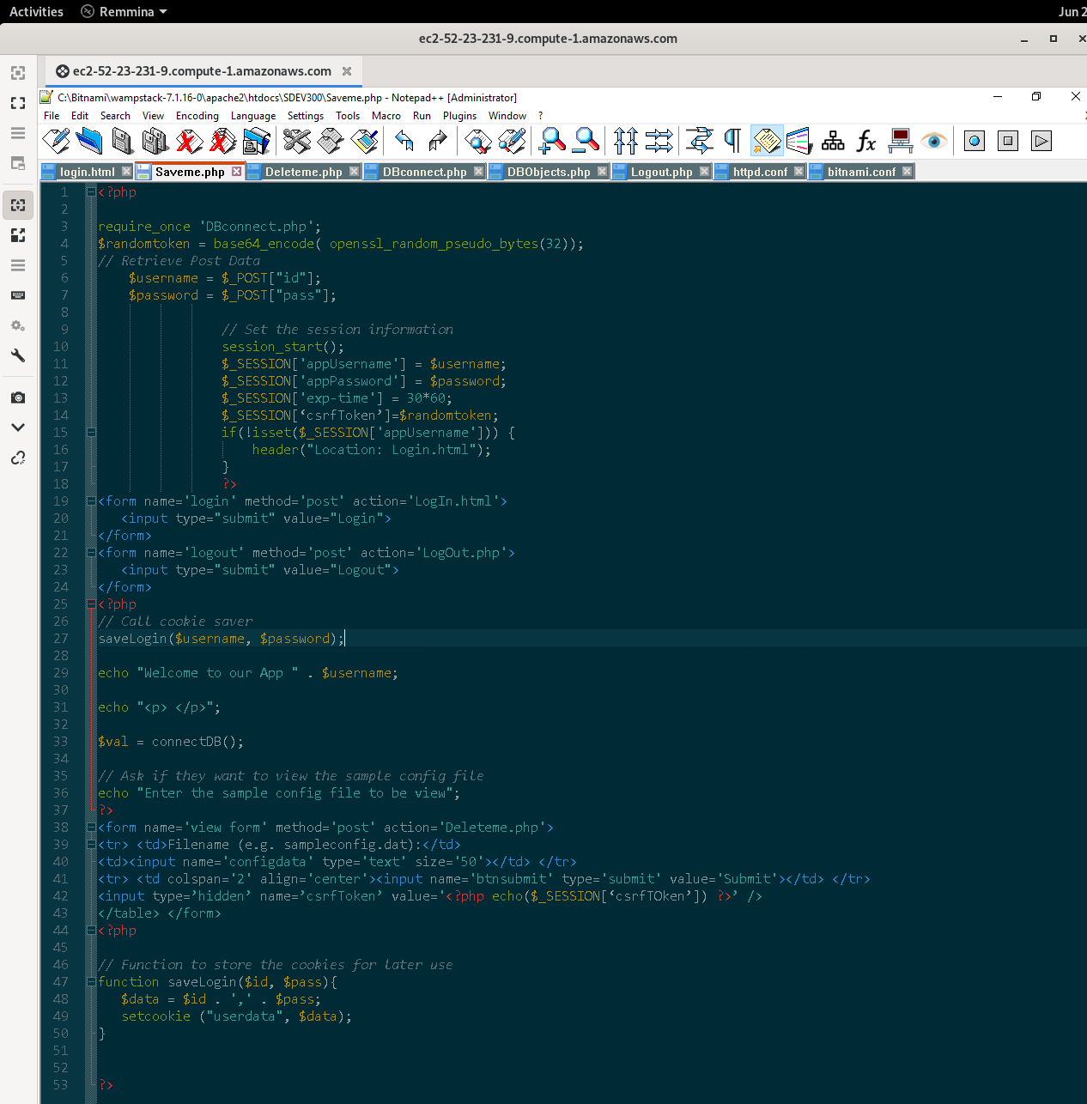

After Security Fixes
